Name: Renee Hedges
The University of Akron
5100:642-800 Introduction to Classroom Assessment
Final Candidate Created Assessment Project
Spring 2012– Dr. Brown

Class Description
Grade Level: 9th Grade Intervention, Special Education Math Class at Schnee Learning Center.

Class Name/Content Area: Algebra.
This class would include a mixture of 8th and 9th grade math standards to best differentiate according to students receiving Special Education Services and other students at-risk according to the Response to Intervention Process.

Class Schedule: The class meets for 70-minute blocks, 5 days a week for an entire 18 consecutive weeks.

Description of Class Content: The class consists of a regular education teacher, highly qualified in Mathematics and one Intervention Specialist licenses to teach High School students with mild to moderate disabilities. The Interventionist is able to focus on intensive intervention with students at the third tier of the Response to Intervention Model while the Math Instructor can facilitate instruction with whole and flex class groupings. The course focuses on high school level Algebraic skills and differentiating instruction based on student readiness. In addition to direct instruction approaches to increase algebraic mastery, students will use computer based instruction and technology to apply, practice and show mastery in content area objectives. Students will apply basic algebraic knowledge to more abstract, grade level standards.

Description of Students: Students within this course is attending Schnee based on personal choice and open enrollment. Schnee Learning Center is a Public-Conversion Community School sponsored by the Cuyahoga Falls City School District. Schnee Learning Center is a credit-recovery school that educates ninth through twelfth grade students who are interested in pursuing a nontraditional high school experience. Many of Schnee students have difficulty achieving in a traditional learning environment and are searching for alternative learning opportunities. “The school provides a continuum of comprehensive strategies to reduce truancy, absenteeism, disruptive behavior, dropouts, and juvenile crime, all of which define the “at-risk” student” (Cardone, 2012). Students are enrolled by individual choice and referred by various community support agencies. Most of the students live in Summit County and reside in the Suburban Areas of Tallmadge, Stow, Kent, Green, Cuyahoga Falls and Munroe Falls. The classroom consists of twenty “at-risk” youth ranging from fourteen through twenty years of age. The classroom would have roughly 75% of students living in poverty and/or other stressful situations (e.g. teen parents, single family homes, addictions, mental illness etc...) Within the full inclusion classroom, are eighty- percent white, non-Hispanic students with a higher percentage of male students. There are six students in the class receiving special education services according to his/her Individual Education Plan (IEP). These students are receiving services such as re-teaching, direct instruction and small group instruction as well as other accommodation and modifications specified on each IEP. Categories for identification would fall in the mild to moderate range (Learning Disability, Severe Emotionally Disturbed, Other Health Impaired or Mild Autism). All other students have strengths and weaknesses in math due to personal experiences and situations. The students will have a continuum of knowledge involving algebra skills.

Unit Topic
Summary of Content The unit would focus on using coordinate plan knowledge to apply skills to more in depth graphing and mathematical processes. Within the unit, students will master applying and using coordinate plan rules and functions within the four quadrants, identify the relationship between the x and y axis, graph the slope and y-intercepts using correct functions or formulas and graph linear equations using two variables. Students would also solve higher level real world application problems to apply the information learned and increase purpose for learning. The unit will apply to grade appropriate standards in Algebra for ninth grade students, but also provide scaffolding using 8th grade standards to close achievement gaps with the population taught.

Length of Unit : The unit is intended to last for 3 weeks, but could be extended based on student need and level of mastery.

Pre-requisite Knowledge Required Prior to Unit: Students would need to be able to solve simple equations and apply the order of operations when necessary. Also students would need to have experience and knowledge of functions.

Standards Aligned with Unit
The Ohio Academic Content Standards aligning within this unit are as follows:
- Understanding Coordinate Planes
-Identify two-dimensional figures in a coordinate plane
2. Graphing Linear Equations in 2 Variables
-Solve and interpret the meaning of 2 by 2 systems of linear
equations graphically, by substitution and by elimination, with and without technology.
3. Identify and Graphing Slope Using y-Intercept Equation
- Describe the relationship between the graph of a line and its
equation, including being able to explain the meaning of slope as a
constant rate of change and y-intercept in real-world problems.
-Compute and interpret slope, midpoint and distance given a set of ordered pairs

Set of Learning Objectives and Taxonomic Levels
Each student will be able to…

1.0 Identify two-dimensional figures in a coordinate plane.

1.1 Identify four quadrants. (Knowledge)
1.2 Graph or identify points using x and y axis. (Application)
1.3 Describe purpose for using coordinate plan information to real life situation. (Comprehension)
1.4 Formulate a graph plan using coordinate plane applications. (Application)
1.5 Develop self awareness using metacognition to identify strengths and weaknesses in coordinate plane skills. (Comprehension- Affective Domain)
1.6 Create real world application coordinate planes. (Application)
1.7 Use T-Charts to graph two sets of numbers that relate to one another. (Application)

2.0 Solve and interpret linear equations in 2 variables.

2.1 Identify the sequence of steps in solving a equation. (Knowledge)
2.2 Solve higher level equations isolating the variable. (Application)
2.3 Graph the solution for a given equation. (Application)
2.4 Evaluate a T chart or table for x and y when given an equation (3x+y=5). (Analysis)
2.5 Plot three points of a solution in a given equation. (Application)
3.0 Compute and interpret slope, midpoint and distance given a set of ordered pairs

3.1 Define the meaning of slope (Knowledge)
3.2 Identify the meaning of y-intercept. (Comprehend)
3.3 Apply knowledge of y-intercept to given slope equation. (Application)
3.4 Graph points on a coordinate plan with a given slope. (Application)
3.5 Determine the equation when given a slope graph (Application)

Overview of Unit Assessment Plan

Week 1:  Coordinate Plane | Day 1 | Pre-Assessment of existing schema-KWL and T/F Anticipation Guide for coordinate plane. You tube History and note taking/discussion (1.1, 1.2)-Pre-Assessment and Schema Building
 | Day 2 | Practice completing functions t- charts and graphing each function on a coordinate plane Technology/Khan Academy, ixl math or Apangea Math (1.1, 1.2, 1.7)-In class Activity/Practice
 | Day 3 | Practice using x and y “t-chart/ (function table) knowledge” with real life word problems. Class Discussion and research building purpose for learning and application (helpwithmath.com) (1.1, 1.2,1.3, 1.7)-Exit Ticket, Formative
 | Day 4 | Review t-chart/function previous day. Identifying careers that use coordinate plan knowledge and apply to real world career (Webquest). Complete a t-chart/function chart given an equation and t-chart (2 sets of numbers that relate to one another). Peer work creating a word problem with each function for real life situation. Share out to the group -Partner Work (1.2, 1.6, 1.7)-In class Activity/Practice
 | Day 5 | Assessment Check/Authentic: Create Battle graph game and play with a partner. Weekly journal/self reflection using given terms. (1.4, 1.3, 1.5, 1.1, 1.2, 1.6) In class Activity, Self Constructed based on rubric.
Week 2:  Linear Equations and graphing using 2 variables | Day 1 | Pre-Assessment of existing schema and review using partner activity and sharing for equations. Review and practice solving equations when given a number for a variable and use for groupings next day. (2.1, 2.2)-Pre-assessment to formulate groupings
 | Day 2 | Differentiated Instruction Groups for Guided equation practice at three levels, solving simple to challenging equations. (2.1, 2.2)-In class Activity/Practice
 | Day 3 | Direct Instruction and practice creating x and y tables to find solutions and graph when given an equation. (2.3, 2.4, 2.5)-Informal Observation and practice- In class Activity/Practice
 | Day 4 | Guided practice creating x and y tables to find solutions and graph when given an equation. (2.3, 2.4, 2.5) In class Activity/Practice.
 | Day 5 | Assessment Check: Tutorial/ Practice/Study/Mastery Exam/Quiz using Plato “Graphing Using 2 Variables” and self reflection exit statement given a graph to state objectives or truths in 2 variables and rating scale. (2.3, 2.5, 1.5
Week 3:  Slope and y-intercepts | Day 1 | KWL of slope, formula y=mx+b meaning and slope instruction-positive, negative, undefined, zero slope (3.1, 3.2)-Pre-assessment and schema building
 | Day 2 | Using y-intercept formula students practice graphing on coordinate plane (3.4, 3.3, 1.1, 1.2) using peer collaboration.-Exit Ticket-Formative
 | Day 3 | When given a graph, create a formula and insert proper numbers for y-intercept using peer collaboration (3.3, 3.5, 1.1, 1.2)- In class Activity/Practice and Affective Domain Assessment (1.5)
 | Day 4 | y-intercept using Plato technology tutorial, application, practice and test individually Quiz (3.1,3.2, 3.3, 3.4, 1.1, 1.2) Unit Test Review Study Sheet- In class Activity/Practice
 | Day 5 | Unit Test: Coordinate Plane with Functions, Solve and Interpret linear equations with 2 variables and y-intercept graphing using slope formula. (1.1-1.7, 2.1-2.5, 3.1-3.5)-Summative

Summative Assessments
Name____________________________ Date______________ Unit Test _____/___pts
Direction: Complete the 40 questions in the 70 Minutes Allotted-65 Points Total
- Follow directions in each section.
- Write your answer in the space provided.
- OGT Calculators are permitted.
- Partial credit can only be given if noted.
Part I: Coordinate Plane
(1-5) Label each statement True or False by writing the entire word. (1 point each) 1.1-1.2
1. The third quadrant on a coordinate plane is in the lower left hand side. __________
2. In quadrant four on the Cartesian coordinate y is positive and x is negative. __________
3. To plot x and y on a coordinates graph one must go left or right then up or down. ________
4. Points (-4,2) would be found in quadrant two. __________
5. Points (0,0) are called Ordinate. _________
(6- 13) Using the graph shown write the coordinates in the box provided. Separate each axis with a comma. (8 Points) 1.2
A. __________
B. __________
C. __________
D. __________
E. __________
F. __________
G. __________
H. __________

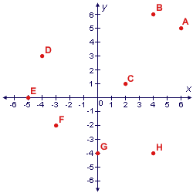

(14-18) There is a $20 annual fee for membership at the gym. It also costs $6 per visit to use the gym. Fill in the function table to show the cost of x visits to the gym. Write the ordered pairs, and graph the data on the coordinate graph.
(2pts each for completing the table and writing ordered pairs=10 Points.) 1.7
y = 20 + 6x
X | Y
0
2
4
6
8
Order Pairs: ( , ) ( , ) ( , ) ( , ) ( , )
19. Plot the points and draw the line graph: (5 pts) 1.4
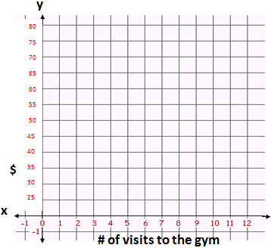

Extended Response/Short Essay-Self Constructed
Answer the following questions in relation to your graph (partial credit can be issued for second part): (4pts) 1.3
20. If you visit the gym 7 times, how much will it cost? _______________________ (1pt)
Describe how this graph could be useful in real life. Make sure you include three different ideas (3pts).
:: ______________________________________________________________________
______________________________________________________________________
____________________________________________________________
:: ______________________________________________________________________
______________________________________________________________________
____________________________________________________________
:: ______________________________________________________________________
______________________________________________________________________
____________________________________________________________

Part II: Solve, Graph and Interpret Linear Equations
(21-23) Solve the following equation and circle the best answer. (1pt each) 2.1, 2.2
21. 5x - 6 = 3x - 8
a. x=1
b. x= -7
c. x= -1
d. x=7
22. 2(3x - 7) + 4 (3 x + 2) = 6 (5 x + 9 ) + 3
a. x=-21/4
b. x=429/2
c. x=-21/2
d. x=-429/4

23. 3/4x + 5/6 =5x -125/3
a. x=10
b. x=490/51
c. x=-10
d. x=-490/51

24 (A). Fill in the T-chart and graph the following linear equation system (10pts). 2.5
2x - 2y = 18
X | Y
0
1

2
24 (B) 2.3

25. Looking at your graph fill in the following statements: 1pt: (2.4)
The graph is in the ________________ quadrant.
The slope is going in a _________________ direction.

Part III: Slope and y-Intercept
Identify the slope for the following graphs and choose the correct answer. (26-27) 1pt Each.
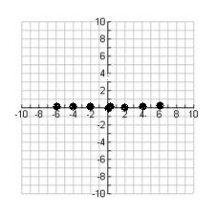
26. The above graph is an example of what kind of slope? 3.1
A. Positive Slope
B. Negative Slope
C. Undefined Slope
D. Zero Slope

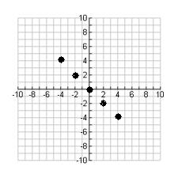
27. The above graph is an example of what kind of slope? 3.1
A. Positive Slope
B. Negative Slope
C. Undefined Slope
D. Zero Slope

28-31. Using the following formula for Slope, identify what each part represents. Fill in the blank with the correct term. 3.1, 3.2 (1pt each)
Identify the components of this linear equation: y=mx+b
28. y= ________________
29. b= ________________
30. m=________________
31. x=________________
Fill in the blank for the following linear equation problems. Use the y-intercept equation y=mx+b (.50 point each=1 pt total)
32 (A)3.1 (B)3.3. For the straight line y = -2x + 3, what are:
a) the slope= _______________
b) the y-intercept= _______________

Use the linear equation for slope to answer questions 33-36.
33. 3.5 What is the equation of the straight line shown in the diagram? y= _______________
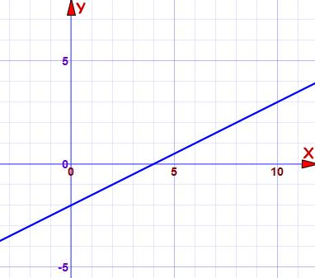

34. 3.5 What is the equation of the following graph: y=________________
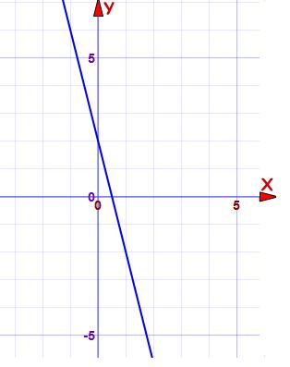

35. 3.5 What is the equation of the straight line shown in the diagram? y= ________________
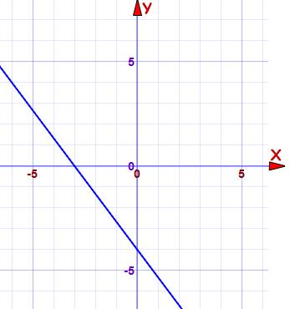
36. 3.5What is the equation of the straight line shown in the diagram? y= _________________
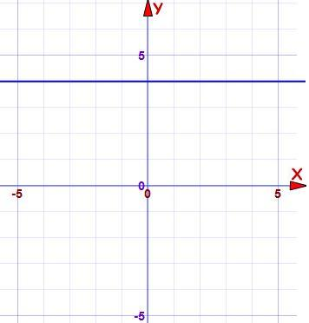

For items 37-34 first graph the equation given then draw the slope line and identify slope direction (positive, negative, undefined or zero) in the space provided. (2pts each) 3.4

37. y = 3x-5 Slope is _______________________________

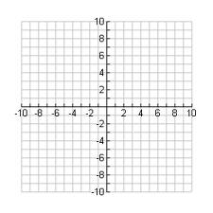
38. y = 1/2 x – 2 Slope is _______________________________
39. y = -4x + 2 Slope is _______________________________

40. y= -4/3x-4 Slope is_________________________

Scoring Model
Summative Assessment Answer Key-65 Points Total

1. True-1pt
2. False-1pt
3. True-1pt
4. True-1pt
5. False-1pt
6-13 (1 Pt each=8 pt total)
A. 6,5
B. 4,6
C. 2,1
D. -4,3
E. -5,0
F. -3, -2
G. 0, -4
H. 4, -4
14-18 (10 Points total)
X | Y
0 | 20
2 | 32
4 | 44
6 | 56
8 | 68
Order Pairs : ( 0 , 20 ) ( 2 ,32 ) ( 4, 44 ) ( 6 , 56 ) (8 ,68 )

19. (5pts)
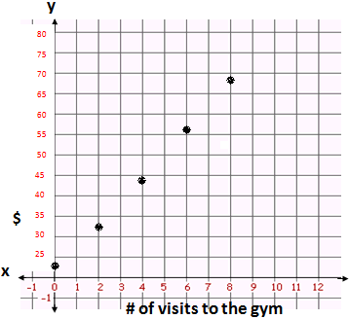
20. $62.00 (1 Pt)
Extended Response/Short Essay (3 Pts): Plausible Answers deemed correct for one point each:

21. C-1pt
22. A-1pt
23. A-1pt

24. (10 pts)
X | Y
0 | -9
1 | -8
2 | -7
3 | -6
4 | -5
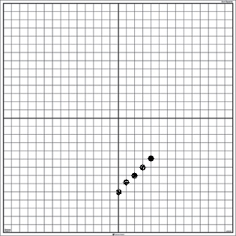
25. Quadrant 4, sloping in a positive direction (1pt)
26. D (1PT)
27. B (1PT)
28. how far up (1pt)
29. Y Intercept (where the line crosses the Y axis) (1pt)
30. Slope or Gradient (how steep the line is) (1pt)
31. how far along (1pt)
32. Slope is -2 and y intercepts is 3 (1pt)
33. y=1/2x-2 (1pt)
34. y= -4x + 2 (1pt)
35. y=-4/3x-4 (1pt)
36. y=4 )1pt)
37. (2pts)
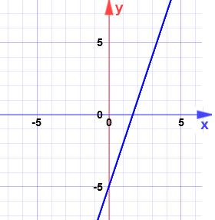 Positive Slope

38. (2pts)
Positive Slope
39. (2pts)
Negative Slope

40. (2pts)
Negative Slope

A few images were used from: http://www.mathsisfun.com/equation_of_line.html (2011).

Objective-Type Assessment: Advantages and Limitations, Accommodations, and Use of Data

Advantages | 1. The questions are versatile.  2. Does not require a lot of writing.  3. Provide clues for misunderstanding.  4. More reliable since subjectivity and judgments is reduced with one correct answer for most of the questions.
Limitations | 1. Guessing can increase with True and False.  2. May focus on trivial items.  3. Lower level questioning bases on Bloom’s Taxonomy, since the assessment is more objective in nature.
How limitations can be minimized or addressed | - Avoid clues for guessing.  - Focus on content that truly matters and correlated to standards.  - Phrase as direct questions without extraneous or lengthy wording.  - Create assessment with some subjectivity questions for higher level thought processes/
Potential accommodations and/or modifications | Accommodations:  Extended Time  Small Group  Highlighter  Read-aloud question(s) and information
Modifications:
The Intervention Specialist could modify the length of the assessment according to Individual Education Plan and coordinate with Mathematics teacher for validity purposes. The mathematics teacher could provide a separate from of the assessment that is modified and used with IEP students receiving modified test questions to increase validity.
How the data from the assessment will be used to inform… | Instruction:  Identify re-teaching groups and mastery level to move on within the unit. The assessment could also identify students that need small group flex instruction with the interventionist to reinforce concepts taught and provide additional guided practice in order to reduce gaps for following units.
 | Students’ Learning: The results will inform students of his/her strengths and weaknesses as well as address content he/she needs to spend additional time practicing for end of the semester, final or state assessments.
 | Quality of Assessment Tool: Using item analysis data could identify the quality of the assessment tool. Identifying p-value and pb-value could indicate discrepancies such as miss-fitting items, incorrectly keyed items and student misunderstandings within class work and exit statements. Other trends could be notes such as the easier and more difficult items.
How the results will be communicated to students and guardians: | Results will be communicated through progress monitoring weekly sheets sent home to families every Monday regarding the previous week grades, mastery of summative assessments and future expectations or goals. Teacher will meet with each student to go over results in a conferencing format.

Self-Constructed Type Assessment: Advantages and Limitations, Accommodations, and Use of Data
#20 on Summative Assessment
Advantages | 1. Restricted Response questions allow students to express own ideas with limits and expectations for correct answers.  2. Allows students to use own strategy for organization.  3. Usually at the application level, so higher cognitive processes are occurring.  4. Using this type of assessment assesses multiple taxonomic levels.
Limitations | 1. Creates low reliability due to subjectivity.  2. This is usually tougher to grade.  3. Sometimes compromised by the hallo effect.  4. I could not give a rubric to students prior to the summative assessment because it would give the answer away.
How limitations can be minimized or addressed | 1. Using an analytic or holistic rubric during grading. I could provide a rubric for grammar expectations.  2. Score grammar and content separately.  3. Minimize halo effect by scoring without names or identifiers.  4. Prepare a list of correct answers prior to grading such as #20 on the summative assessment and provide to students after grading assessment to ensure fairness and feedback.
Potential accommodations and/or modifications | Accommodations: Extended Time, Small Group, Graphic Organizers and Highlighters would be provided according to individual IEP or 504 plan.  A scribe could be provided with specific directions for validity (student identifies beginning and ending punctuation as well as identifies starting a new paragraph etc..) if the IEP specifies such a modification.
 | Modifications: The Interventionist could modify this section of the test from three answers to two answers and would need to adjust scoring for validity and reliability reasons.
How the data from the assessment will be used to inform… | Instruction: Using constructive type of questions provided an in depth picture of student mastery and knowledge using higher cognitive processes. It identifies confusion, mastery and generalization for either re-teaching or enrichment opportunities.
Students’ Learning:
This provides feedback on how well students expressed mathematical thinking in writing.

 | Quality of Assessment Tool: Plausible checklist of answers will be used in order to provide written feedback and reason for points given. Inconsistencies in answers or common answers not found on the checklist could indicate an issue with the answer document.
How the results will be communicated to students and guardians: | Both descriptive and evaluative feedback would be provided to identify reason for grade given.

Formative Assessments

Name________________________________________________ Exit Ticket 1-Function Charts and Graphing

Date_______________________________ Objectives: 1.2, 1.6, 1.7
Directions: Using the following function problem, create an x and y function table using the information provided. Don’t forget to label x and y on your table. Graph your function table using the coordinate Plane provided. Don’t forget to give your graph a title. You have 15 minutes to complete the table and graph for 9 participation points total. In order to get all the participation points, you need to show your work and thinking through each step.

Problem: Schnee Learning Center enrolls students each month during the school year. From August through January, 6 new students are enrolled each month. Create a function table to identify how many students are enrolled through January. Create, label and connect the dots on your coordinate plane to show the trend.

Function Table Coordinate Plane
.
Name________________________________________________ Exit Ticket 2-Slope and y-Intercept

Date_______________________________ Objectives: 3.1, 3.2, 3.4

Directions: Using the slope formula given for y=mx+b, graph the following slope. Identify the type of slope your graph represents on the line provided. You have 10 minutes to complete this graph for a total of 9 participation points. In order to get all the participation points, you need to show your work and thinking through each step.

y= -7/4x + 3
Describe how you knew what to do. What were you thinking to do first? How did you plot the points?

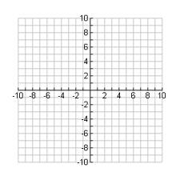
What type of slope is this? _____________________

Advantages and Limitations, Accommodations, and Use of Data
Exit Tickets
Advantages | 1. Exit ticket keeps students on task and focused on learning goals.  2. Exit tickets identify what students can do and what needs re-taught.  3. Exit ticket provides student feedback on areas they need to improve or do better in.  4. Exit tickets help build on constructs and creates connections between learning.
Limitations | 1. These are less formal and are often not used towards grading, so students might not take them as seriously.  2. Students that have difficulty with mastering concepts or get feedback that is constantly negative, can impact self-efficacy in a negative light.
How limitations can be minimized or addressed | 1. I chose to award participation points for formative assessments to increase motivation and gave it less weight in overall grading. 2. Ensure feedback is non- threatening or tied to consequences. Feedback should encourage students and ensure more opportunities for mastery and re-teaching.
Accommodations: Students with Individual Education Plans or 504 plans might need extended time, small group, directions clarified and highlighters.
Some students might need the word problems read aloud.

 | Modifications: (none). This is an assessment to see what the students know. Modifying the content would hinder the purpose of this assessment. Keeping it at is, would give the teacher more accurate information for structuring future lessons.
How the data from the assessment will be used to inform… | Instruction: Exit tickets would assist in planning instruction more tailored to student need for the purpose of differentiating targeted groups of students.
 | Students’ Learning: Exit tickets identify strengths and weaknesses which provided feedback to students in order to clarify confusion and misconceptions.
 | Quality of Assessment Tool: I would look at inconsistencies in student responses to identify exit tickets that might signal a problem with the general construction of the assessment. In addition, I would look for discrepancies between higher and lower level ability students. For instance, if I know a student has been doing well on function tables during class work, and then does not do well on the assessment, I would need to investigate further to identify the reason for this discrepancy.
How the results will be communicated to students and guardians: | Written feedback would be provided on each exit ticket. Conferences would also be held with individual or groups of students to discuss areas of need. During parent-teacher conferences, I would keep a few formative assessments in each student’s portfolio in order to show mastery and progression.

Assessment of Objective Under Affective Domain

Directions: (1) Read each math activity in the 8 columns and rates your feelings towards your understanding of the task stated by placing an “x” in the box that best describes how you feel towards that activity. Be honest with your answers. This will be used to help me re-teach concepts that are unclear. This will also help me give you proper feedback on what to study and review prior to our unit test. You will get 15 participation points for filling out this rating correctly. Points are not based on your comfort level, but merely on your participation with this survey. (2) Add up each column and place the number in the space provided. (3) Add up each column and place the total on the line provided. (4) Complete the 2 boxes below to identify your strengths and weaknesses.

Student’s Algebra Self-Assessment (Objective 1.5)

Scoring Criteria | Plotting points on x and y axis and identifying quadrants | Creating a function table when given a story problem | Solving Simple Equations with minimal operations | Solving more difficult equations with more operations | Creating a coordinate plane graph when given an equation with 2 variables | Explaining slope terms | Identifying the parts of slope equation | Identify and graphing slope and y-intercepts.
4 Points

Extremely Comfortable

3 Points

Comfortable

2 Points

Uneasy

1 Point

Clueless

Score
Total In Each Column
Column Total _________________________________

Skill Comfort Rating Scale
34-31 Extremely Comfortable
30-28 Comfortable
24-27 Uneasy
23 or below Clueless

My 3 strengths in Algebra are……

My 3 weaknesses in Algebra are…..

Advantages and Limitations, Accommodations, and Use of Data
Student Algebra Self Assessment
Advantages | 1. Encourages meta-cognitive practices and mind mapping.  2. Encouraging students to self monitor own learning.  3. This could be adapted to other units.
Limitations | 1. Difficult to give an value grade to feelings.  2. Student may not be honest, which can interfere with reliability and validity.
How limitations can be minimized or addressed | 1. Only give participation points.  2. Discuss the purpose and keep information private.
Potential accommodations and/or modifications | Accommodations: Extended Time, Scribe if needed and read aloud survey. This could also be given as a teacher survey where the student verbalizes the information while the teacher writes in responses.
 | Modifications: I could allow a student to identify fewer than 3 strengths and weaknesses.
How the data from the assessment will be used to inform… | Instruction: Information will give me data for review and differentiated instruction focus groups.
 | Students’ Learning: Students will be able to identify areas to focus and study.
 | Quality of Assessment Tool: This tool can help prepare summative assessment review and can be an indicator of success or failure.
How the results will be communicated to students and guardians: | The results could be used during the Response to Intervention process for intervention and tutoring services. Individual results would be communicated through individual conferencing in collaboration with the Interventionist and math teacher.

Specification Table

Item (or Assessment Part) | Objective Number(s) | Rationale (How it aligns)
Summative Assessment(s): Algebra Unit Test
Question 1 | 1.1 | Students identify one of the four quadrants on a coordinate plane
Question 2 | 1.1 | Students identify one of the four quadrants on a coordinate plane.
Question 3 | 1.2 | Students acknowledge proper directionality in identifying x and y coordinates.
Question 4 | 1.2 | Students use coordinate points to identify quadrant.
Question 5 | 1.2 | Students identify the meaning of (0,0)
Question 6 | 1.2 | Students name x and y coordinates using a coordinate plane.
Question 7 | 1.2 | Students name x and y coordinates using a coordinate plane.
Question 8 | 1.2 | Students name x and y coordinates using a coordinate plane.
Question 9 | 1.2 | Students name x and y coordinates using a coordinate plane.
Question 10 | 1.2 | Students name x and y coordinates using a coordinate plane.
Question 11 | 1.2 | Students name x and y coordinates using a coordinate plane.
Question 12 | 1.2 | Students name x and y coordinates using a coordinate plane.
Question 13 | 1.2 | Students name x and y coordinates using a coordinate plane.
Question 14 | 1.7 | Students create a T-Charts/Function Table when given a story problem and equation.
Question 15 | 1.7 | Students create a T-Charts/Function Table when given a story problem and equation.
Question 16 | 1.7 | Students create a T-Charts/Function Table when given a story problem and equation.
Question 17 | 1.7 | Students create a T-Charts/Function Table when given a story problem and equation.
Question 18 | 1.7 | Students create a T-Charts/Function Table when given a story problem and equation.
Question 19 | 1.4 | Students graph real world function table using coordinate plane knowledge.
Question 20 | 1.3 | Students demonstrate real world application in using coordinate plane graphing and function tables through reasoning application to real world ideas.
Question 21 | 2.1 | Students solve the given equation.
Question 22 | 2.2 | Students solve the given equation using proper steps in isolating the variable.
Question 23 | 2.2 | Students solve the given equation using proper steps in isolating the variable .
Question 24A | 2.5 | Students use given equation to complete T-chart and graph the linear equation system.
Question 24B | 2.3 | Student use completed T-Chart to graph x and y axis.
Question 25 | 2.4 | Students evaluate T-chart and graph to identify quadrant and slope.
Question 26 | 3.1 | Students identifies slope with given coordinates.
Question 27 | 3.1 | Students identifies slope with given coordinates.
Question 28 | 3.2 | Students use slope formula to identify meaning for y.
Question 29 | 3.2 | Students use slope formula to identify meaning for b.
Question 30 | 3.2 | Students use slope formula to identify meaning for m.
Question 31 | 3.2 | Students use slope formula to identify meaning for x.
Question 32A | 3.2 | Students use slope formula to identify slope and y-intercept when given a linear equation.
Question 32B | 3.3 | Students identify y-intercepts
Question 33 | 3.5 | Students will use the graph given to create linear equation using y=mx+b.
Question 34 | 3.5 | Students will use the graph given to create linear equation using y=mx+b.
Question 35 | 3.5 | Students will use the graph given to create linear equation using y=mx+b.
Question 36 | 3.5 | Students will use the graph given to create linear equation using y=mx+b.
Question 37 | 3.4 | Students graph given slope using given linear equation and identify slope direction.
Question 38 | 3.4 | Students graph given slope using given linear equation and identify slope direction.
Question 39 | 3.4 | Students graph given slope using given linear equation and identify slope direction.
Question 40 | 3.4 | Students graph given slope using given linear equation and identify slope direction.
Formative Assessment
Exit Ticket 1 | 1.6 | Student uses a real-world situation to create a function table and graph coordinates on a coordinate plane to identify process, mastery and confusion.
Exit Ticket 2 | 3.4 | Student graphs given slope using linear equation and identifies slope direction to identify process, mastery and confusion.
Affective Assessment
Student Self Assessment | 1.5 | Student uses reflection for self evaluating purposes and progress monitoring for the purpose of re-teaching and studying.

Grading Period Plan
Grading Framework: For this unit, I chose a criterion-reference grading framework because each assessment looks at mastery in specific domains and standards. I will be teaching criterion based on state standards, curriculum framework and identified learning targets. More specifically, I will be identifying precision of performance, quality of performance and using points and percentage for grading purposes.

Final Marking System: Letter grades will be used for final marking. The marking system will coincide with the district grading system. Since the district does not institute a homework policy, homework will not be factored into the overall grade.

Final Mark Percentage Label: The unit would be out of 193 points and weighted according to the pie chart in the components section. Grades would be kept in progress book and final grades would be determined using the following percentage system:

A | 90-100% | Exemplary
B | 80 - 89% | Very Good
C | 70 - 79% | Satisfactory
D | 60 - 69% | Needs Improvement
F | Below 60% | Failing

Components Included in the Final Marking: During the 18 week semester, there would be six units including the one presented in this project. A larger percentage of the unit would be weighted on in class assignments and the overall unit test. Since Direct Instruction and practice is a large part of Schnee;s curriculum, in class work is a better gage of student mastery and in my opinion, deserves a percentage of weight close to the summative assessment weight. Weighted percentages would include the following: 18% Pre-assessment Participation (6% x 3 assignments), 8% Affective Domain Activity, 9% Formative Assessment Participation (4.5% x 2), 10% In Class Quizzes (5% x 2), 24% In Class Work (4% x 6), 31% Unit/Summative Assessment. This unit would be worth a total of 193 points based on the final marking below.

Determination of Final Marking: The composite grade will be determined by fixed percentage and point values.

